**Question 1 HW4**

The question asks to Consider the Diabetes dataset and fit LDA QDA and RDA to it.

**Step 1 Loading the dataset**

I loaded the dataset using load function which is provided in the home work



**Step 2 Making pairwise scatter plots**

By using clpairs functiuon that is present in “mclust” package I made the pair wise scatter plots and plotted the legend, and also observed the following things

* It can be observed that data is normally distributed
* The classes NORMAL and CHEMICAL_DIABETIC are strongly corelated and each class is having different co-varinaves.

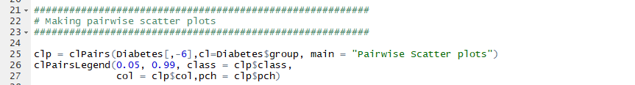

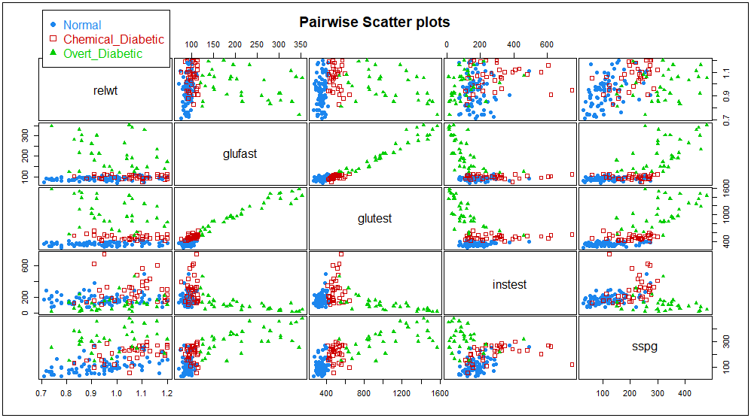

**Step 3 Splitting the dataset**

I set the seed to 45 for getting the same results, and sampled the datset using sample function with 70% of data into Training set and 30% to test set. And also conveted the categorical response variable into numeric variable diabetes = 0; noraml =0 as shown below.

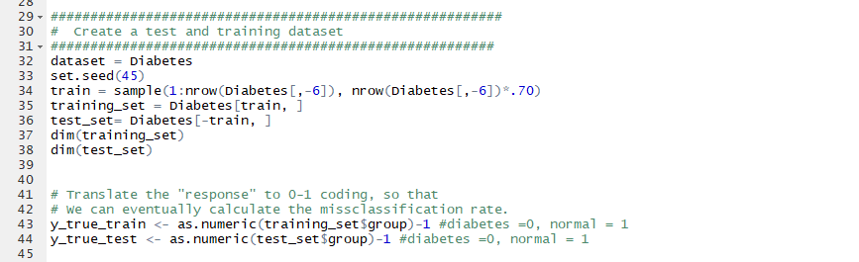

**Step 4 1 B Fitting LDA**

By fitting the lda model to the dataset using lda(). And on claculating the errors after predicting the results using predict () function it is observed that the train and test errors appears to be **0**.**099** anf **0**.**136** respectively

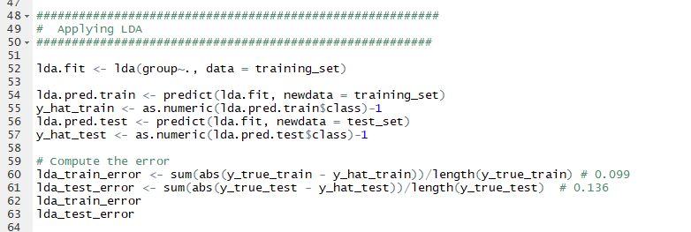

**Step 5 1 B Fitting QDA**

By fitting the lda model to the dataset using qda(). And on claculating the errors after predicting the results using predict () function it is observed that the train and test errors appears to be **0**.**049** anf **0**.**068** respectively

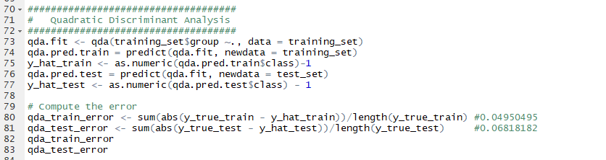

**Step 5 1 B Fitting RDA**

By fitting the lda model to the dataset using qda(). And on claculating the errors after predicting the results using predict () function it is observed that the train and test errors appears to be **0**.**0693** anf **0**.**1363** respectively

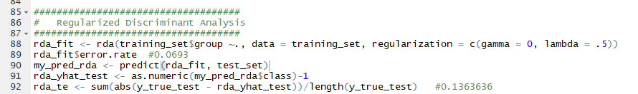

* **QDA performs better than LDA her with less train and test errors.**
* On comparing the three models **qda** appears to be having better test error of all the three.

**Step 5 1C predicting the given values**

One fiiting the values to the given model it appears that lda assigns to “NORMAL” class and QDA assigns to “Overly_Diabetic” class.

